NAME : ABINESH.N

Reg-No : 73152114001

E-Mail : [abineshn493@gmail.com](mailto:abineshn493@gmail.com)

Title : SQL lab-practice-1

Table - I ( CLIENT_MASTER )

1) select *from CLIENT_MASTER;

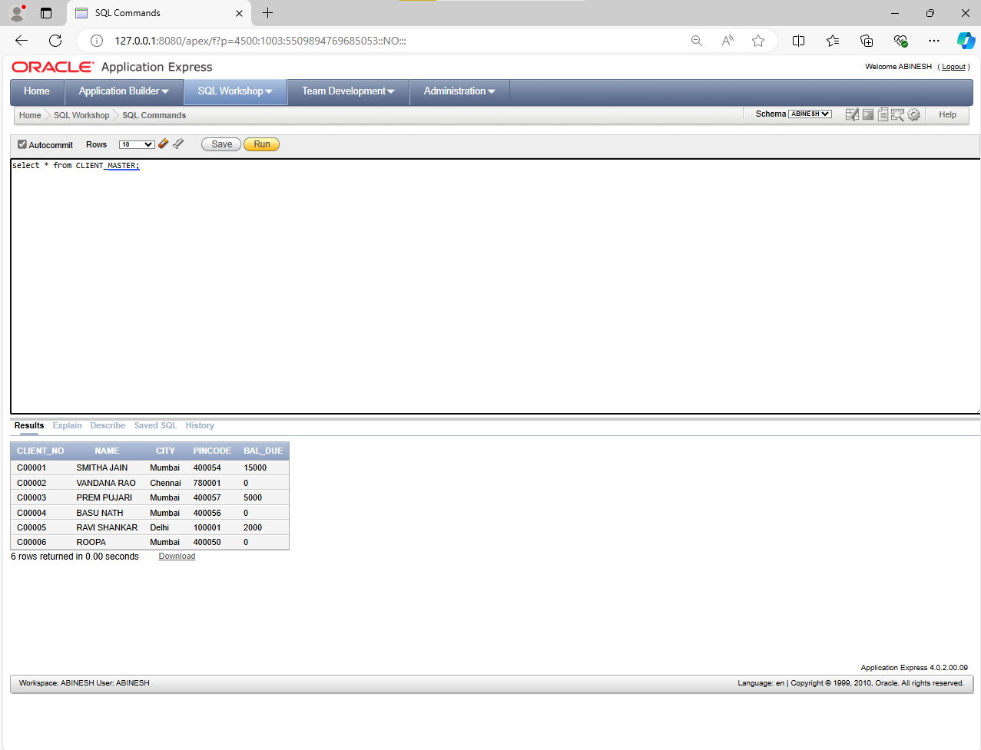

2) Table - II ( SALE_ORDER)

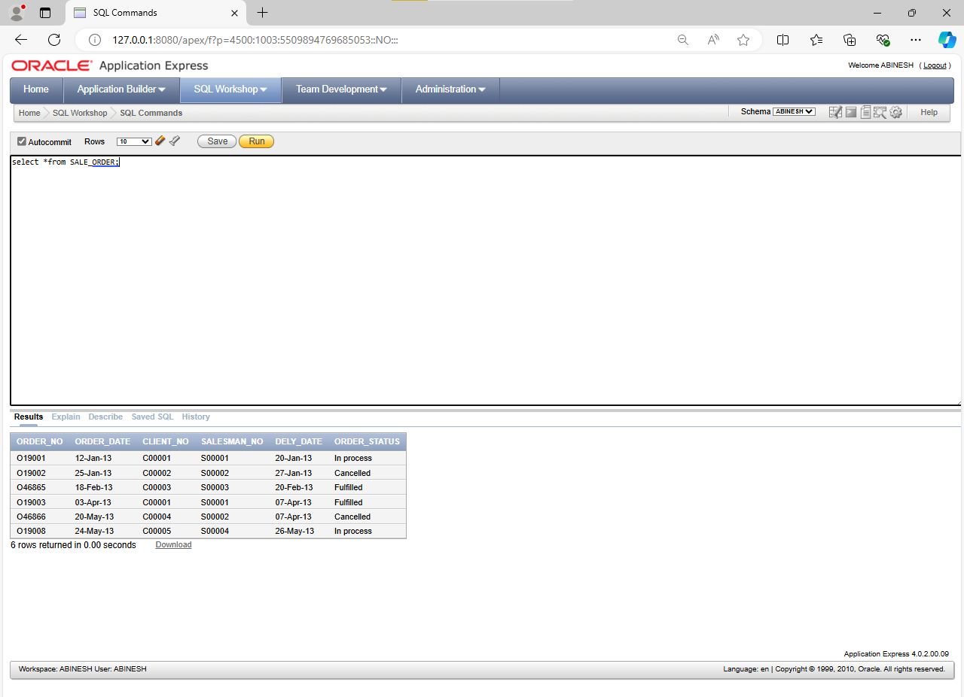

3)List all details from the client_master table for clients whose Bal_due = 0.

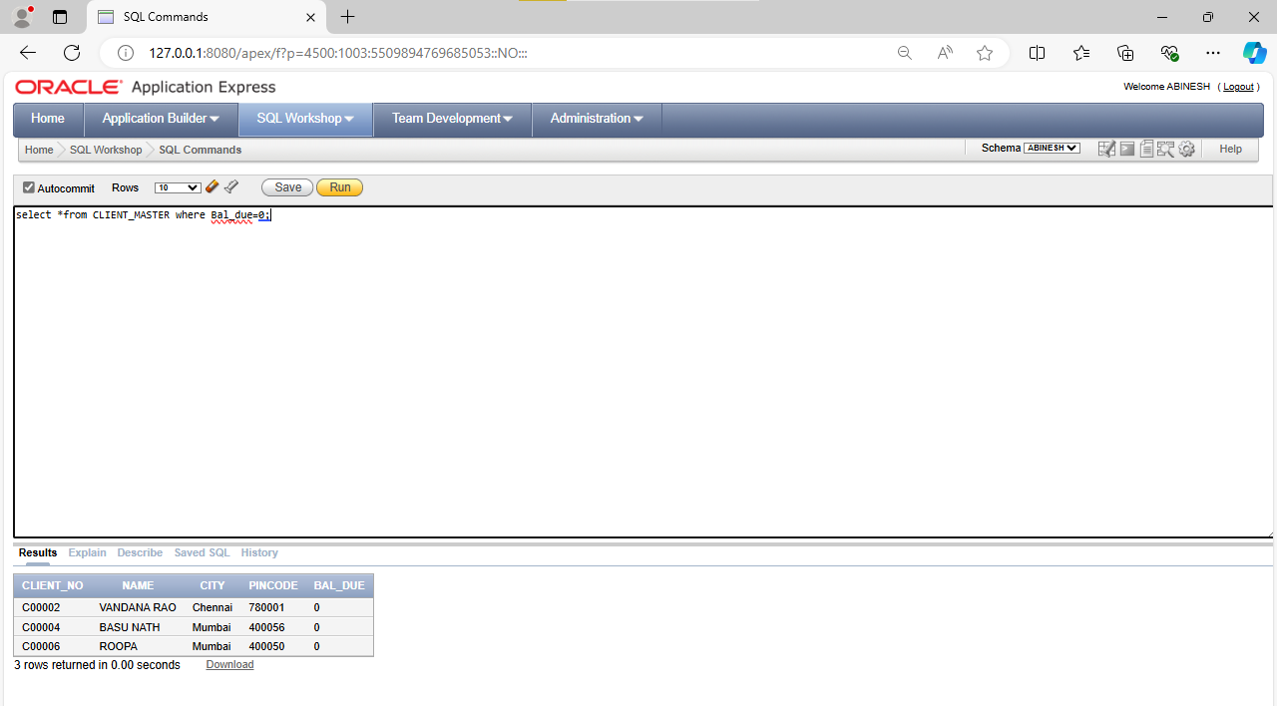

4)Update table client_master, Change city of Client_no C00004 to Jaipur.

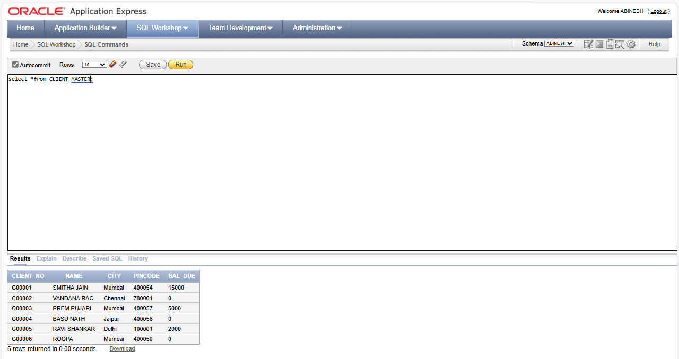

5)Retrieve records of clients residing in Mumbai.

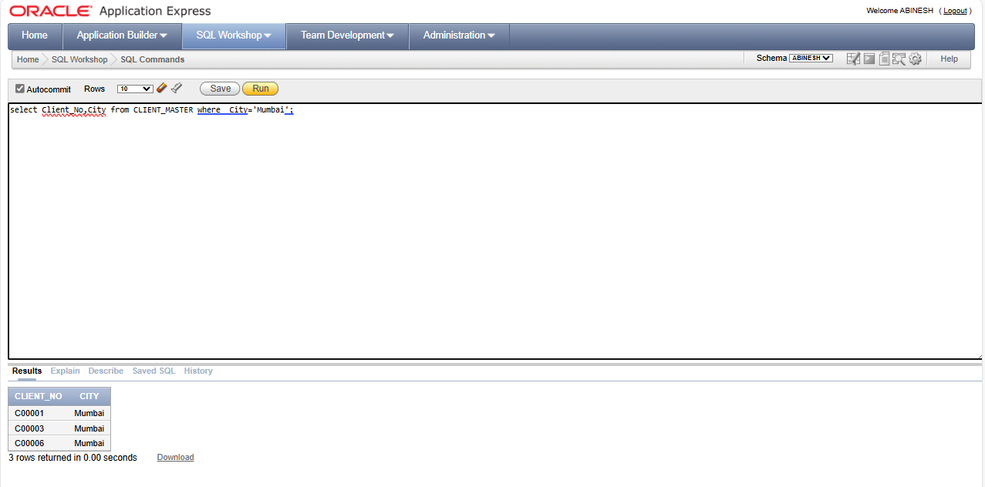

6)Find the name and address of customer who has placed Order_no 'O19003' and 'O19002' respectively.

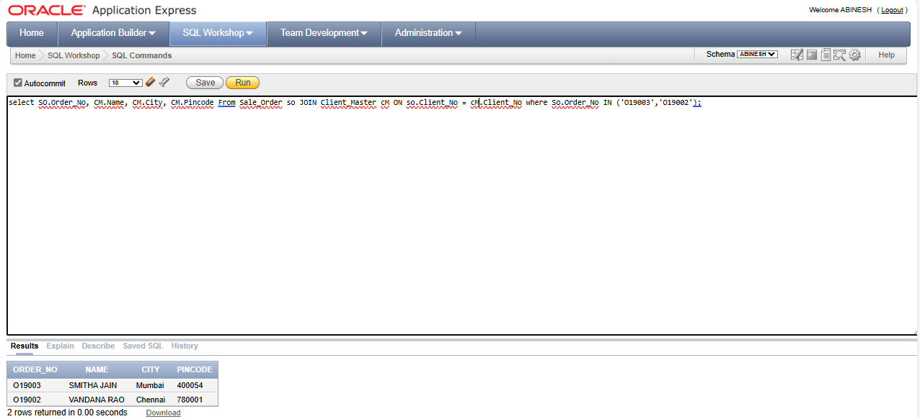

7)Construct English like sentence from the table client_master ({Customer name} live in the city of {city}).

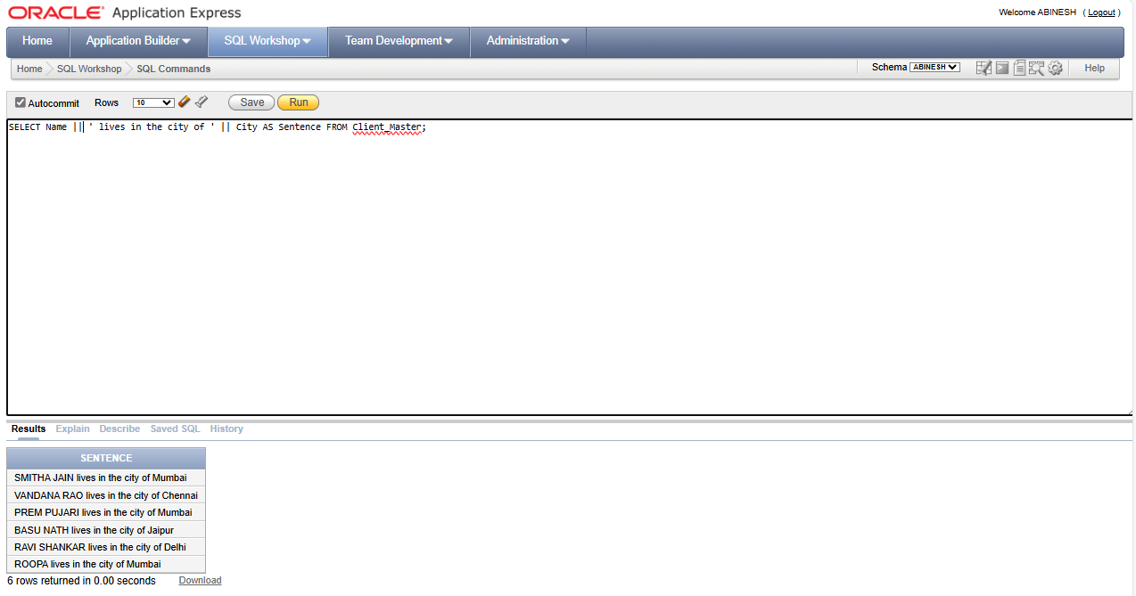

8)List the client_no, name, city and pincode of clients whose Order_status is "In process".

